graduated last year, from Imperial, with a master degree in biomedical engineering, specialised in neurotechnology. And I studied medical physics at UCL for my undergraduate degree. Nice to meet you all, and It’s a pleasure for me to have this interview opportunity today.
Keywords: inhibitory and excitatory neurons, dopaminergic neurons
Lab Approaches: Rodent behavioural tasks, two-photon calcium imaging, fiber photometry, in vitro and in vivo electrophysiology, optogenetics (k) and intersectional viral labeling strategies (k), anatomical.
Theme: systems neuroscience, circuit mechanisms that transform information into action
Purpose and Duties: experimental design, implementation (with guidance) and running behavioural experiments; perform optogenetic, anatomical and in vivo electrophysiological experiments; administration work on animal colony; perform genotyping; safety, ethical and data protection, organizational skills and keen interest.
Requirements: Knowledge in Neuroscience, physics; Python and equivalent coding language; communication, management (prioritise, multi-task),organizational skills; effectively alone and in team; interpersonal and research ethics ( accountable, reliable, resourceful, ethically…); desirable independent research experience with evidence (RA and team leading?), reinforcement learning literature, theory and modeling (modules, computational and BMI coursework!, model and decoding task)
Personal alignment: Techniques – wet lab, accurate and organised handling , with detailed observation and record keeping (i.e. review protocol paper, terminology, routine works for maintenance avoiding contamination, and experimental plan, stocking and calculation, and following/adapting procedures, with examples, multiple environmental factors tracking e.g. incubation, light, troubleshooting), electrophysiological data, (group project) calcium imaging (staining protocol?) with 2p (experience with operation two-photon microscope)
Soft: Organizational, responsibility, patient and careful management animal colony, troubleshooting, communication in administration work (manufacturer, other lab and expertise, especially in this work with a restrict timeline, timing between each step, i.e. primary and secondary ) and interests (system neuroscience, behavioural training, develop new tasks & experiments and own project)
Interpersonal: long-term improvement (previous supervisors and boss feedback), passion-driven, strong interests in research
Presentation: structured like project introduction; answer questions
Supporting information:
Lab research related knowledge
System neuroscience: study the structure and function of neural circuits and systems in the brain. Aiming to understand how networks interact to produce complex behaviors, perceptions and cognitive functions. Act as a bridge between molecular and cellular neuroscience to cognitive neuroscience.
Animal Colony: referred to a controlled population of rodents, bred and maintained for research purposes.
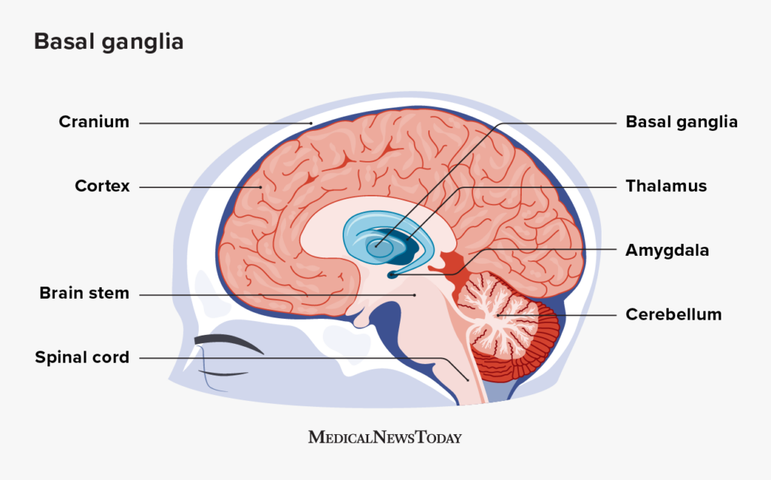
The mechanisms by subcortical circuits transform information into purposive action. Transforming sensory information and internal states into purposive behavior, from basic reflexes to complex actions. Key processes: 1. Sensory processing and integration, thalamus act as a relay station, receiving sensory inputs, routing them to the appropriate cortical areas for further processing, also integrates and filters sensory information; 2. Motivation and emotion, hypothalamus and amygdala, mediating motivated behaviors like sexual activity, feeding. Process information related to internal states, also connects with the limbic system, influencing emotions and stress responses; 3. Action selection and motor planning, basal ganglia and cerebellum, action selection and initiation of voluntary movements, receive input from various cortical areas and integrate information to make decisions, both facilitating desired movements and inhibiting unwanted ones, with a neurotransmitters, Dopamine involved. Cerebellum with fine-tunes motor commands, involved in motor learning; 4. Execution of motor commands, brainstem and spinal cord, after the formulated motor plans, they are transmitted to the brainstem and spinal cord which execute the motor commands by activating the appropriate muscles, while also modulates these commands based on feedback from sensory systems, allowing for quick adjustments; 5. Feedback and adjustment, cerebellum and basal ganglia, monitoring the outcomes of actions and adjusting future behaviors accordingly. Error correction during movement, ensuring that actions are precise and adaptive.
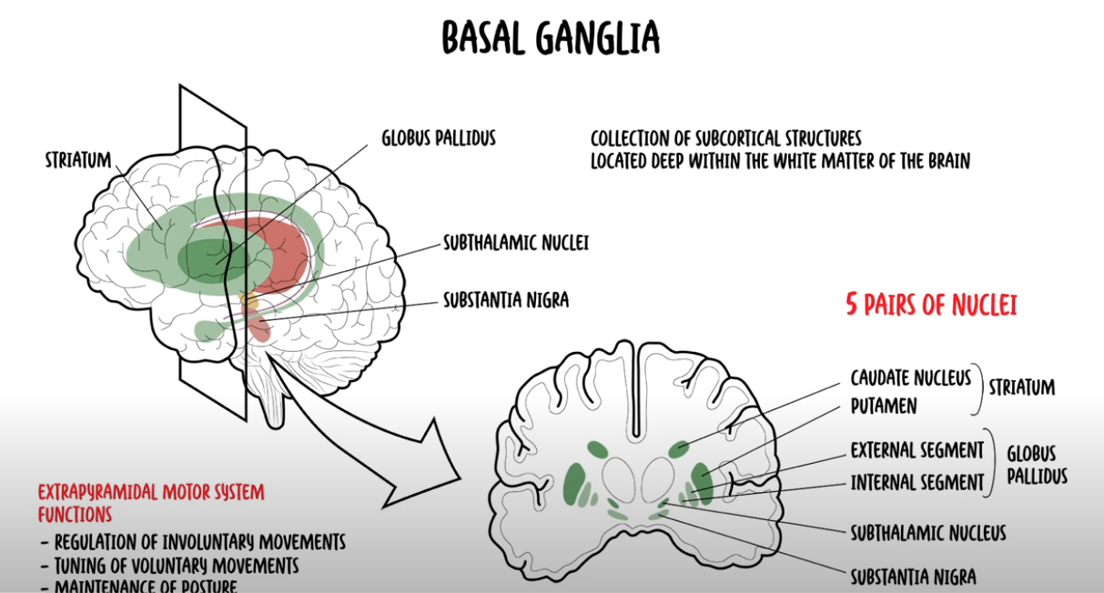
Nuclei inside the basal ganglia:
Striatum ( caudate and putamen): receives inputs from the cerebral cortex, excitatory glutamatergic neurons. Substances contain projection neurons and interneurons and inhibitory neurons which release GABA. The axons of the neurons form the direct and indirect pathways of basal ganglia which project into the globus pallidus (GP) and the subthalamic nuclei.
Globus pallidus: mainly GABAergic projection neurons, fire spontaneously and irregularly at high frequencies. Direct pathway from striatum to internal part of globus pallidus (GPi) is the motor loop, indirect pathway from striatum to external part globus pallidus (GPe) . Both contribute to modulation of the motor pathways. Create smooth and precise motor actions, inhibitory action to balance the excitatory component.
Subthalamic nucleus: modulation of planned motor movements, receive input and give output to the GP, contain glutamatergic neurons.
Substantia nigra: motor nucleus, located at anterior part of the midbrain, made up of the pars compacta (supplies the striatum with dopamine) and the pars reticulata (serves as an output, conveys signals from the basal ganglia to the thalamus).
All these connections allow for a regulation of involuntary movements. Efferents/outputs towards the thalamus and brainstem. Afferents from cerebral cortex, substantia nigra (enable movement initiation, termination and modulation); thalamus, (fibers are glutamatergic, responsible for excitatory effects, thalamostriatal pathway, mark in blue).
Functions: primary to fine-tune voluntary movements, receives and processed impulses, conveys instructions to the thalamus, which sends back to the cortex and then to the skeletal muscles via the pyramidal motor system. Preventing unwanted, excessive movements. Others include reward processing, reward and motivation, decision making, working memory and eye movements.
Clinical anatomy: Parkinson disease, hypokinetic disorder, result of neurodegeneration of dopaminergic neurons in substantia nigra, reduce dopamine supplies to the striatum, causes the symptoms of motor dysfunction. Huntington’s disease, hyperkinetic disorder, produce excessive abnormal and involuntary movements cognitive degeneration and psychiatric dysfunction. Caused by genetic error, lead to neuronal death in putamen and caudate of the basal ganglia. No cure but treatment to inhibits uptake of movements, by reduced the synaptic vessels, and stimulation of striatum. Other disorder include hemiballism, tourette synorome (sudden, repetitive uncontrol movements and sound)

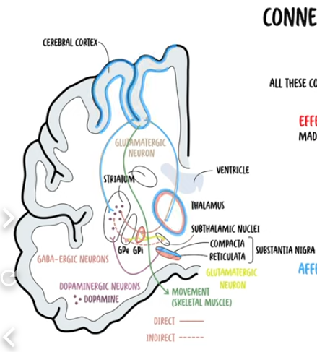
Bidirectional responses: the basal ganglia is a system that integral to motor control, habit formation and reinforcement learning. The bidirectional response refers to the ability of basal ganglia circuits to modulate behaviour based on the expectation of positive or negative outcomes. Direct (reward-related) with dopamine release on D1 receptors in the striatum, enhances activity in the direct pathway and promotes behaviours that are linked to positive outcomes and indirect (punishment-related) pathway with dopamine acting on D2 receptors in the striatum reduces activity in the indirect pathway, inhibits actions thus preventing/suppressing behaviours associated with negative outcomes. Dopaminergic
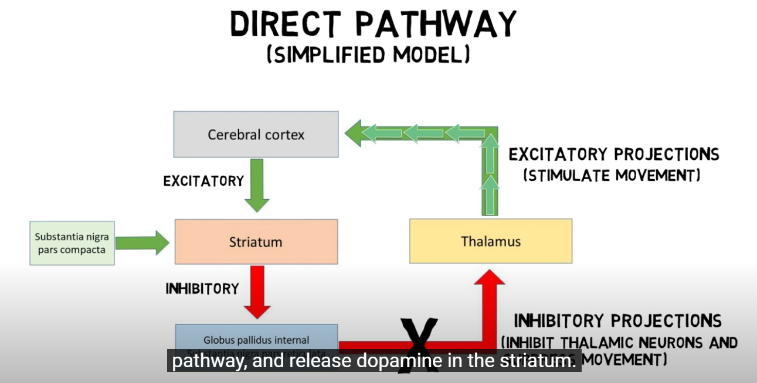
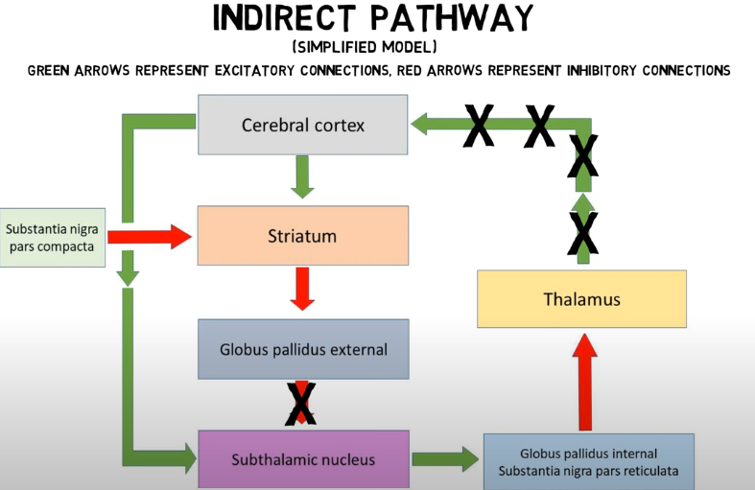
Paper Summary:
A basal ganglia circuit for evaluating action outcomes
Conclusions: individual GPh neurons bidirectionally encode the expected value of an action as well as the value of its outcome; the inhibition or excitation of the GPh influence behaviour, which is fundamental to its role in evaluating action outcomes. However, not influence the selection of actions;
Methods and Data analysis:
- Optogenetic, surgery and immunohistochemistry
- Classical conditioning task
- In vivo electrophysiology, signal processing, multiple neurons, bandpass filtering, spike and firing rate.
- GPh neurons identification, unsupervised clustering approach with light response, principal component analysis, receiver operating characteristic
- Data analysis – raster plots to spike density functions, Gaussian kernel, cross-correlation on waveforms across sessions to classify same unit recording
Previous knowledge and research
Computational neuroscience
Reinforcement learning:
- Temporal difference learning: time until give reward, take into account the total future expected reward. Fire at stimulus rather than at the reward time after training.
- Compare to unsupervised (in cerebral cortex, mainly) and supervised learning (in cerebellum, motor learning, mainly), reinforcement learning (in basal ganglia)
Combination with physics:
- Magnetism, the inspiration of the Hopfield network, spin signs in time step
- Probabilistic in neurons, with a slope or step function if the condition is deterministic
Mathematical Methods
- PCA
Electrophysiological signal processing
- Raw signal processing: high-pass filtering and amplification
- Time window, MAV and mean absolute gradient, to sine wave variables
I designed a wearable device to record EMG signals from the forearm, processing and translating these signals into audio signals for auditory biofeedback to aid in muscle control improvement. The prototype included a sensor with attached electrodes, an external signal filtering circuit, and was integrated with a microcontroller for programming. The real-time EMG signals were recorded and processed using Arduino, where the muscle signal features were decoded and mapped for auditory feedback generation.
Spike trains/ in vivo/ single units (BMI project)
- Two steps approach to predict hand movement positions
- Naïve Bayes classifier to classify orientations, posterior probability, p of class C given the data X (features)
- follow by orientation-specific feedforward neural networks regressor for real time position prediction
Cerebral organoid
- Immunochemistry
Tracking Changes in Brain Organoid Spontaneous Activity Over Maturation: This project aimed to investigate the impact of temperature on the neural dynamics of iPSCderived cerebral organoids and to engineer solutions for better mimicking the brain’s internal regulatory environment in vitro. I developed a temperature regulation system embedded in an imaging chamber to track neural activities in organoids. The objectives were to analyse calcium dynamics across various developmental stages, providing insights into maturation features and early neural computation, and to validate the potential of iPSC-derived brain organoids as a model for studying neurodegenerative diseases.
Research Vision
- Attention improves motor learning and performance. Through enhances relevant stimuli, improving decision-making and motor responses (check attention notes). Example of eye fixation in dance and workout.
- Emotion effect, dopamine level, increased activity in the indirect pathway
Research proposal draft:
Structure
- Keyword
- What is the inspirations of the research question to the questions itself
- Current results/research
- Research gap ,
- Aims and objectives
- Research methods (which carried in the lab), experiments

Information
‘Principles of Neural Science’
22. (Perception) The Bodily Sense – the dorsal root ganglion neuron is the shared sensory receptors in the somatic sensory system. One of the somatic sensibility’s modalities, proprioception, the sense of static position and movement of the limbs and body. Mechanoreceptors and sensorimotor, sense coded in body
38. Voluntary Movement – the somatotopic organization of the motor cortex is plastic, each premotor area contributes to different aspects of motor plan
39. The Control of Gaze – six extraocular muscles, controlled by three cranial nerves; distinct systems control smooth pursuit, vergence and gaze; and saccades generated in the brain stem, controlled by cerebral cortex, the ocular motor nuclei in the brain stem, parasagittal section through the thalamus, pons, midbrain and visual attention cerebellum.
Related to the lab work: basal ganglia circuits, across various areas
Cover Letter
Structure:
Main idea: Shown strong interests in systems neuroscience. Relevant experience around the main experimental tasks required, like in vivo electrophysiology and optogenetic – had EMG, electrophysiological recording, signal processing and analysis + calcium imaging with in vitro model, brain organoids. Research skills emphasis on organisational, research development, communication and collaboration. (no animal experience however eager to learn)
- General introduction, interests in systems neuroscience, animal study/behavioral tasks, and relevant experiences.
- Knowledge, neuroscience from molecular to higher level, processing+programming computational modeling and BMI, machine learning and data analysis.
- Practical skills, applicable experience in techniques, like 2p microscopy, electrophysiological recording etc. Research skills include safety, responsibility and independent research experience
- Research vision, strong interests in the research topic and willingness of pursue PhD in the lab (how internal states and external information filtered and processed in the neural circuits, with the collaboration of various system like sensory (input), motor(output), broad application, act as a bridge)
- Finishing up
Note:
- Read relevant Computational Neuroscience note
Dear Dr. Stephenson-Jones Team,
I am writing to express my strong interest in the Research Assistant position in your lab focused on systems neuroscience. My academic and research background, combined with my deep passion for brain science, aligns closely with the requirements of this role. Throughout my academic journey, I have developed a profound interest in the complexities of brain mechanisms, particularly in how neural networks produce cognitive decisions and behaviours. My previous work in electrophysiological signal decoding and brain stem cell model observation has provided me with valuable insights into the challenges of both interpreting physiological signals and understanding cellular mechanisms. However, I have come to realise that a comprehensive understanding of the brain requires bridging the gap between molecular and behavioural levels, an endeavor that systems neuroscience is uniquely suited to address.
My educational background in Physics with Medical Physics has equipped me with a solid foundation in theoretical concepts, particularly in multi-modal biomedical imaging techniques, including light and advanced microscopy. During my master’s studies, I further enriched this knowledge by focusing on neural data processing and analysis, where I applied computational approaches to gain a better understanding of the nervous system. Through simulations of computational models such as neuronal electrical properties, signal integration, reinforcement learning and other learning and memory models in MATLAB, I developed a deep understanding of how dynamic and statistical theories from physics and mathematics can be applied to computational neuroscience.
In addition to theoretical knowledge, I have honed practical skills in electrophysiological recordings and brain imaging data analysis through various research projects. For instance, I worked on decoding monkey movement trajectories from single and multiple unit recordings, which enhanced my ability to process large neural datasets and apply machine learning techniques. Moreover, I have refined my programming skills in Python, MATLAB, and C++ through engineering and biomedical applications, including processing data from EMG, ultrasound and advanced microscopy.
My research skills, developed across diverse lab environments, are highly transferable to this position. In my previous role as a research assistant, I independently conducted experiments to characterise an ultrasound system using a newly launched GUI. This involved designing experimental procedures, analysing data for software parameter calibration, and drafting end-user guidelines for a multidisciplinary audience. These tasks strengthened my abilities in data management, project development, troubleshooting, and effective communication with both team members and external collaborators. During my master’s project on neurodegenerative disease model study, I cultured cerebral organoids derived from human and mouse induced pluripotent stem cells to investigate early-stage neuronal development. This wet lab work required precise sample management, experiment scheduling, and strict protocol adherence, significantly improving my administrative skills. Additionally, I gained practical experience with techniques such as two-photon calcium imaging, which I believe would be directly applicable to the work in your lab. I am also highly motivated to gain hands-on experience in behavioural training with animal models. My commitment to delivering high-quality work through personal dedication and thoughtful collaboration, coupled with a strong sense of responsibility and safety in laboratory settings, would enable me to contribute effectively to your research team.
I have also developed my interpersonal skills through various work and volunteering experiences. These experiences have taught me the importance of contributing to an inclusive and respectful environment, as well as maintaining ethical standards and confidentiality in all aspects of my work. Leading a team of seven and serving as the presenter for a journal club and poster presentation have further enhanced my teamwork and collaboration abilities. I have demonstrated accountability and resourcefulness in delivering effective communication, organising multiple tasks, and making adjustments to ensure the success of any project.
My curiosity and motivation in systems neuroscience stem from not only from my academic journey but also from my personal life, where I approach cognitive feedback with a self-experimental mindset. Living in an era of information explosion and rapid AI advancements, it has become an inevitable challenge for individuals to process, select and make decisions amidst overwhelming external information. This drives my fascination with understanding how the human brain integrates the inputs and modulates internal states. The possibility of discovering interactive approaches and unraveling the mysteries of brain mechanisms is particularly compelling to me.
With my background in physics and neuroscience, I am excited about the potential to combine physics and mathematical models with experimental evidence in contributing to the field of theoretical neuroscience. I believe that the opportunity to work as a research assistant in your esteemed lab would be invaluable for advancing my knowledge and practical skills in neuroscience research. I am also keen to pursue a PhD in the near future and have a strong interest in the research topics at the Sainsbury Wellcome Centre. I hope to have the opportunity to pursue my PhD in this dynamic environment.
I am eager to contribute to and learn from your team, and I am excited about the potential growth and development this position offers.

Yours sincerely,
Chuqi

- Practical skills, applicable experience in techniques, like 2p microscopy, electrophysiological recording etc. Research skills include safety, responsibility and independent research experience. communication, management (prioritise, multi-task),organizational skills; effectively alone and in team; interpersonal and research ethics ( accountable, reliable, resourceful, ethically…);

Other draft: My research experience with in vitro electrophysiological recording, EMG, which aimed to externally translate muscle signals to audio signals, for the application of biofeedback
My knowledge background in neuroscience and physics and experience in multi-disciplinary lab environments have equipped me to contribute effectively to research development, from both the theoretical and practical aspects, while maintaining a strong sense of responsibility in the laboratory settings.
faulty reasoning/cognitive and behaviour negative feedback (accurate wording)

